Out today! Our paper in @NatureMedicine linking rising temperatures with increases in suicides, assaults, drownings and transport accidents. Summary below. @ImperialCollege @ImperialSPH @Columbia @EarthInstitute @Harvard @HarvardChanSPH @nature: https://www.nature.com/articles/s41591-019-0721-y

Temperatures that deviate from the long-term local norm affect human health, and are projected to become more frequent as the global climate changes. There are limited data on how such anomalies affect deaths from injuries.

We used data on mortality and temperature over 38 years (1980–2017) in USA and formulated a Bayesian model to quantify how warmer temperatures affect deaths from unintentional (transport, falls and drownings) and intentional (assault and suicide) injuries, by age group and sex.

We found that a 2°C anomalously warm year, as envisioned under the Paris Climate Agreement, would be associated with an estimated 2,135 (95% credible interval 1,906–2,368) additional injury deaths (1% increase of total injury deaths)

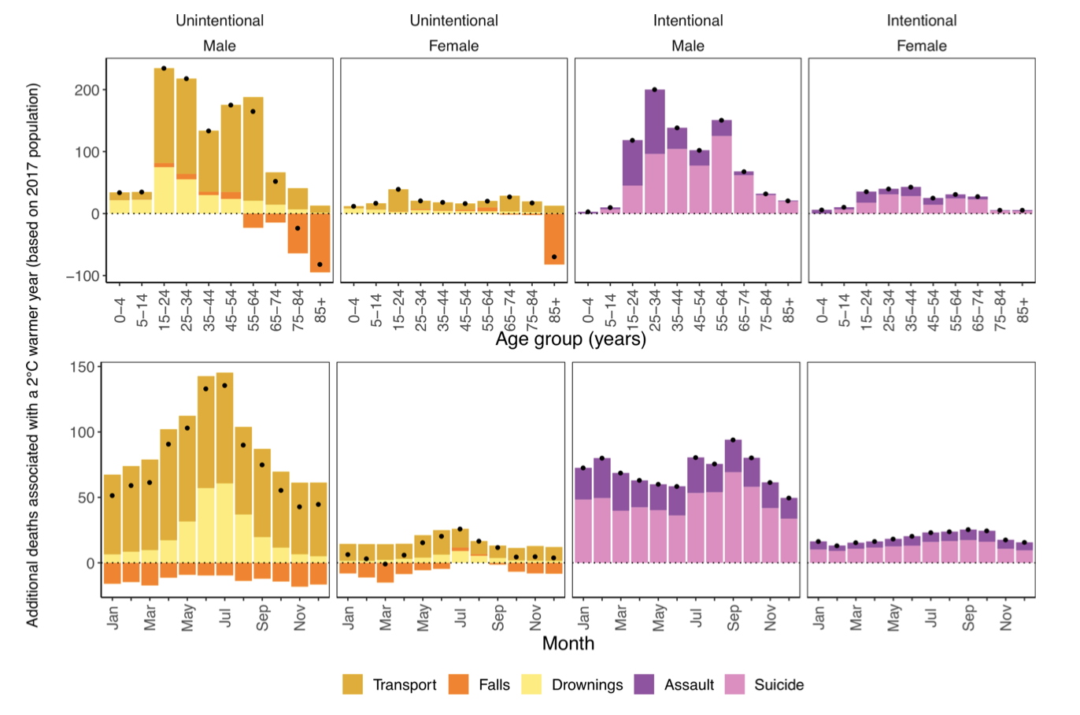

Of these additional deaths, 84% would occur in males, mostly in adolescence to middle age. These would comprise increases in deaths from drownings, transport, assault and suicide, offset partly by a decline in deaths from falls in older ages.

The findings demonstrate the need for targeted interventions against injuries during periods of anomalously warm temperatures, especially as these episodes are likely to increase with global climate change.
On a personal note, this is the culmination of almost five years of work as a PhD student. It has been a long and rocky road, but one which I have loved doing. Thank you to my co-authors especially.

The paper is also the subject of the cover art for the @NatureMedicine issue. Huge thanks to @amykatewolfe who illustrated our paper findings for the cover https://amykatewolfe.com

People to @:

@francescadomin8

